General Steps

Step 1. Download Virtual Tour Framework 2

Step 2. Create Virtual Tour with Marzipano Tool and 360 images 2

Step 3. Customise Virtual Tour to your Organisation 4

Step 3.1 Implement Web Design 4

Step 3.2 Integrate 360 images 5

Step 3.3 Integrate MaplinHotspots and VideoHotspots 5

Step 3.4 Integrate Accessible Sub-Grouped Menu 7

Step 4. Learning Record Stores (LRS) Set Up 9

Step 4.1 Create Learning Record Store account 9

Step 4.2 Connect your website to the LRS and send statement 10

Step 4.3 Run a Test 10

Step 5. Host your Virtual Tour using Amazon S3 (AWS S3) 11

Step 6. Create 3D Environment with Mozilla Hub and Add link to 12

Step 6.1 Create 3D environment and Link 12

Step 6.2 Get Link to Allow Users Log In 14

## Download Virtual Tour Framework

1. Download Github repository <https://github.com/Insa-Maria/Virtual_Tour> by clicking on the green button “Code” and then “Download ZIP”
2. Save “Virtual_Tour-master.zip” and “Extract all”

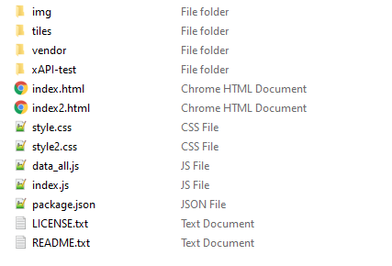

1. For future reference, this folder will be called “Virtual_Tour_Framework” in this tutorial.

## Create Virtual Tour with Marzipano Tool and 360 images

1. Navigate to <https://www.marzipano.net/> (you can explore some Demo and Documentation
2. Click on “Marzipano Tool”, top left button
3. Click on “Start” and “Select files” to add the 360 images

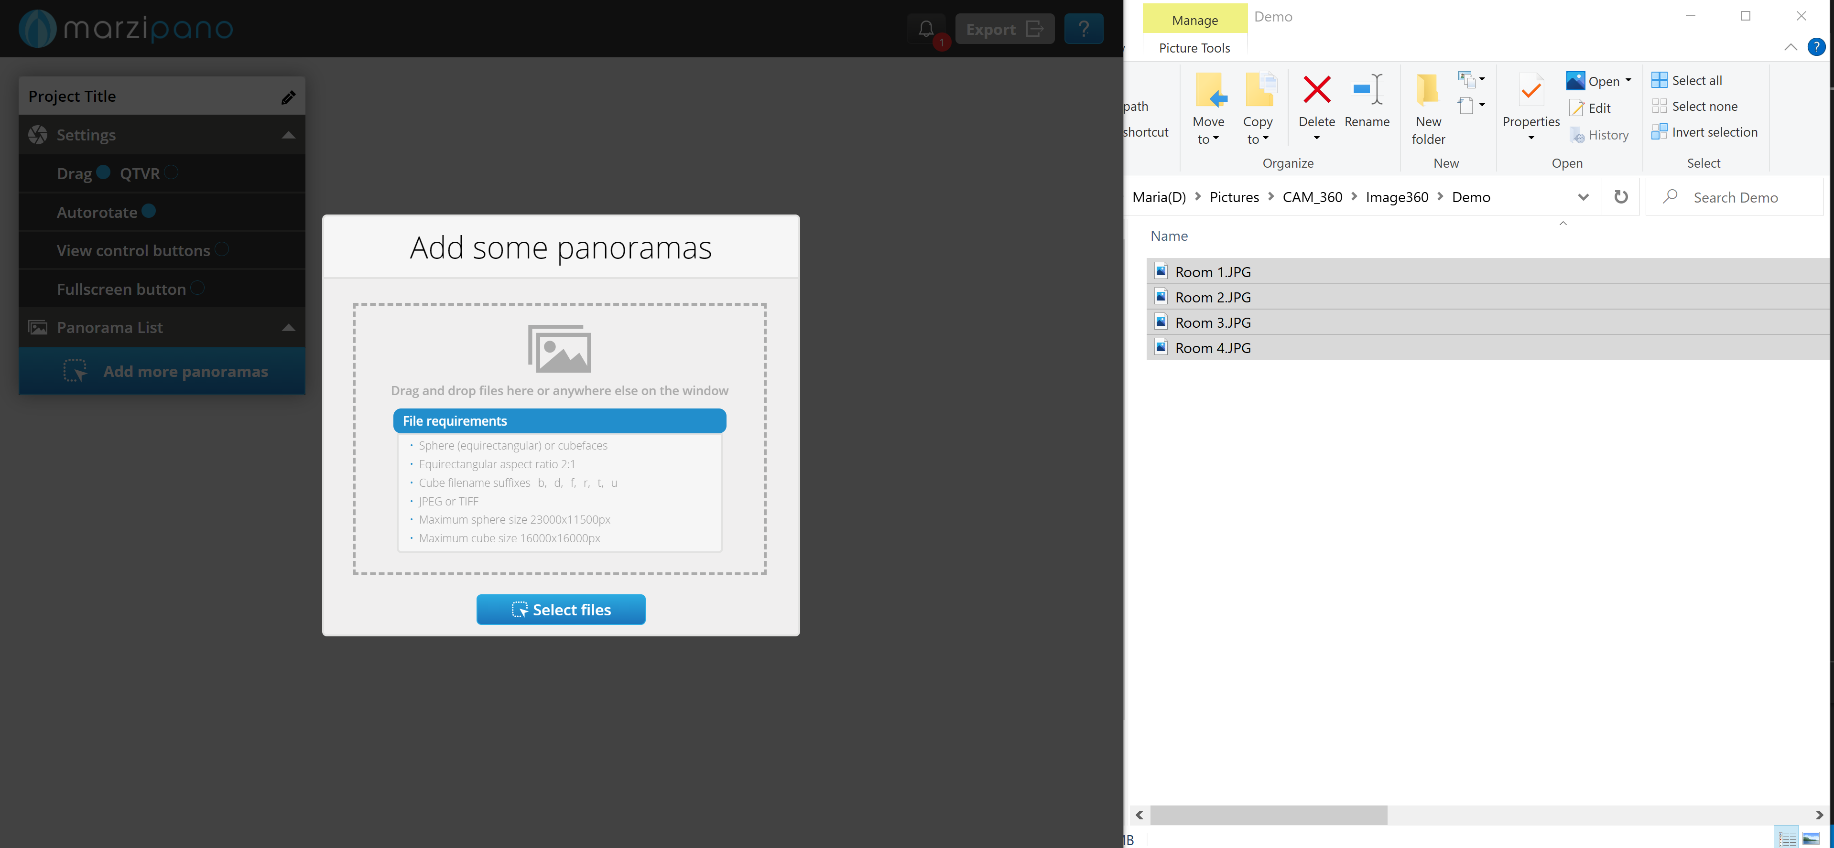  
Note: By default, the file name is set as the 360image title in the web-based Virtual tour.

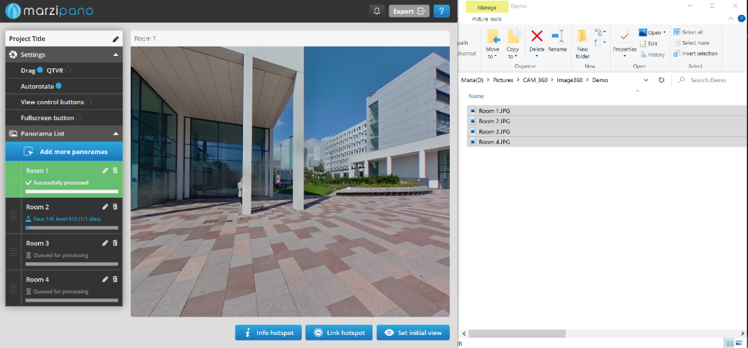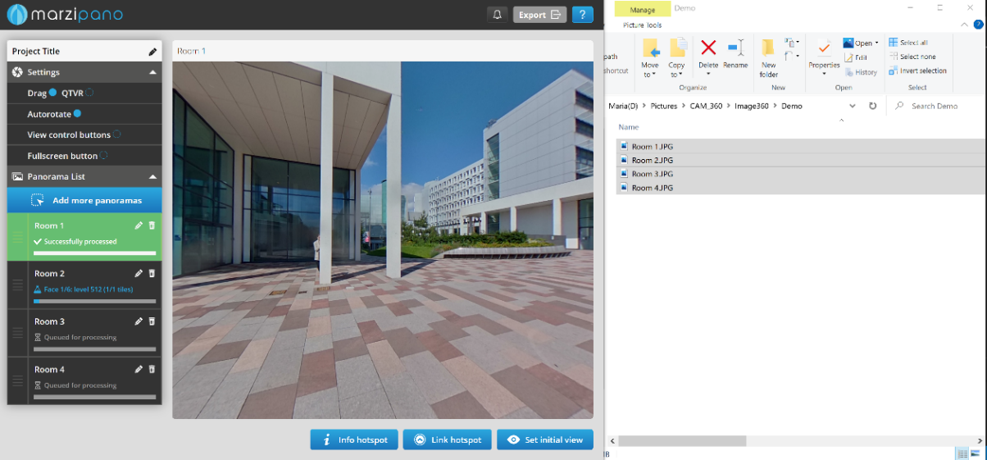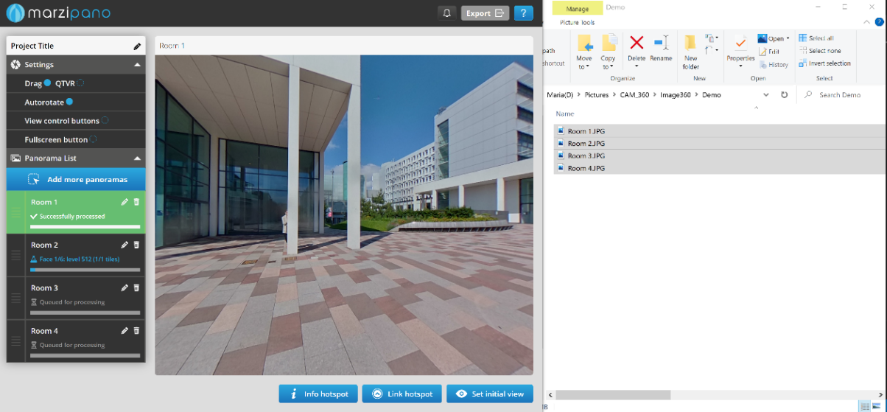

1. Set the “Project Title” and “Settings”
2. Export the project by clicking on the top left button. Save the .zip file (i.e. project-title.zip) and "Extract all”
3. Open the “project-title” folder and open the folder called “app-files”
4. To run the Marzipano Virtual Tour, right click on the “index.html” file and open with a browser (i.e. Google Chrome).  
   Note: A black screen with the “info” button may appear and the menu bar may appear. To fix this error:

(1) close ALL Google Chrome,

(2) on your windows bar, search for “Run” app,

(3) type “Chrome with --allow-file-access-from-files %1”

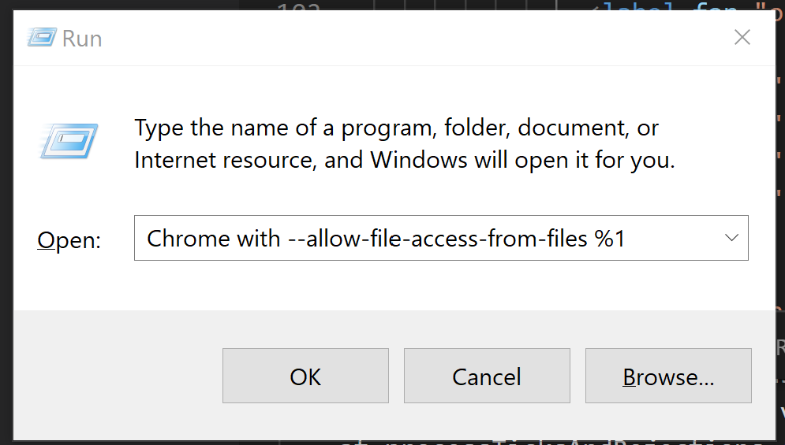

1. For future reference, this folder will be called “Marzipano_Virtual_Tour” in this tutorial.

## Customise Virtual Tour to your Organisation

In this section, “Marzipano_Virtual_Tour” files are edited and copied to “Virtual_Tour_Framework” folder.   
*Note: I highly recommend after each step, run the “Organisation_Virtual_Tour/index.html” file, (right click on the “index.html” > open with a browser (i.e. Google Chrome)) to ensure the changes are performed correctly.*

Open on two different windows:

1. “Organisation_Virtual_Tour” folder (downloaded from GitHub)
2. “Marzipano_Virtual_Tool” folder (exported from Marzipano Tool)

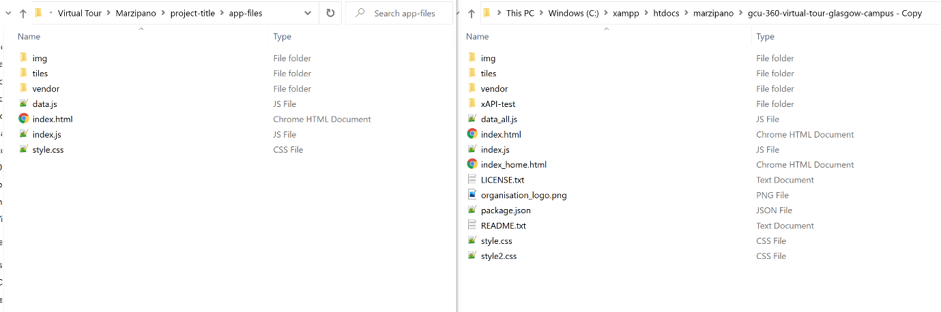

### Implement Web Design

1. Copy and Replace the “Marzipano_Virtual_Tool/style.css” file to “Organisation_Virtual_Tour” folder.
2. 

Organisation_Virtual_Tour

Marzipano_Virtual_Tour

1. Delete all folder in tiles from “Organisation_Virtual_Tour” folder

### Integrate 360 images

1. Open “Organisation_Virtual_Tourttiles” and delete all folders. Open “Marzipano_Virtual_Tool/tiles” , copy-paste the folder to Open “Organisation_Virtual_Tour/tiles”

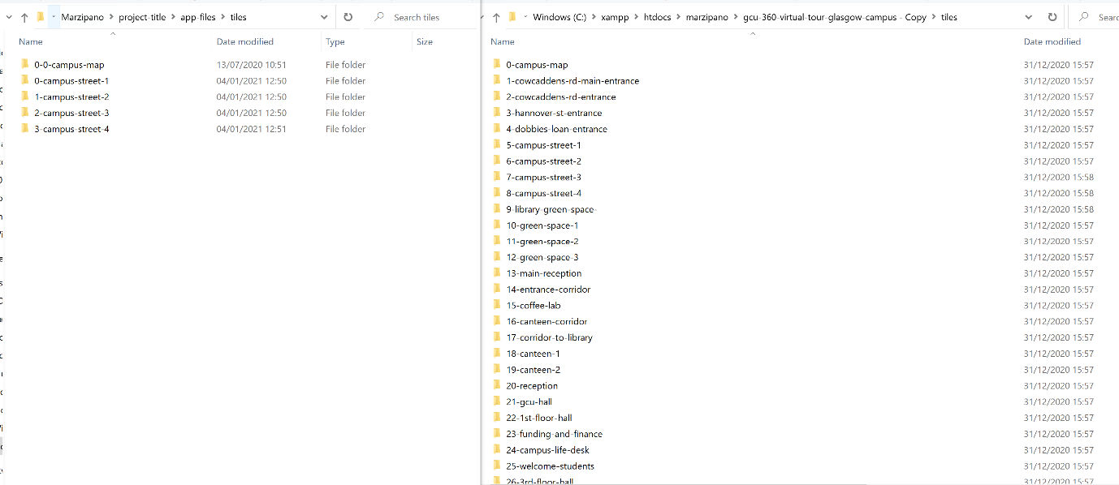

Organisation_Virtual_Tour > img

Marzipano_Virtual_Tour > img

### Integrate MaplinHotspots and VideoHotspots

1. Duplicate your “Marzipano_Virtual_Tool/data.js” file and save it somewhere in your desktop for future reference.
2. 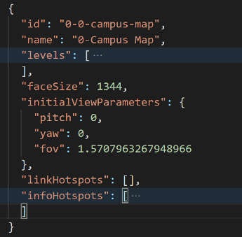Open “Marzipano_Virtual_Tour/data.js” file using an editor note (i.e. Visual Code).   
     
   The data.js collect all data relevant to 360 images (called scene, according to marzipano terminology) added to the Virtual Tour with the “info” and “link” hotspots. It is coded the following way:

* id
* name
* levels
* faceSize
* initialViewParameters
* linkHotspots
* infoHotspots

The proposed system introduces two more elements: “maplinkHotspots” and “videoHotspots”.

1. To the “Marzipano_Virtual_Tour/data.js”, add the bellow code to ALL scenes (which start with “id”) after “infoHotspot”: [ … ] :

,

      "maplikHotspots": [],

      "videoHotspots": []

See an example bellow image:

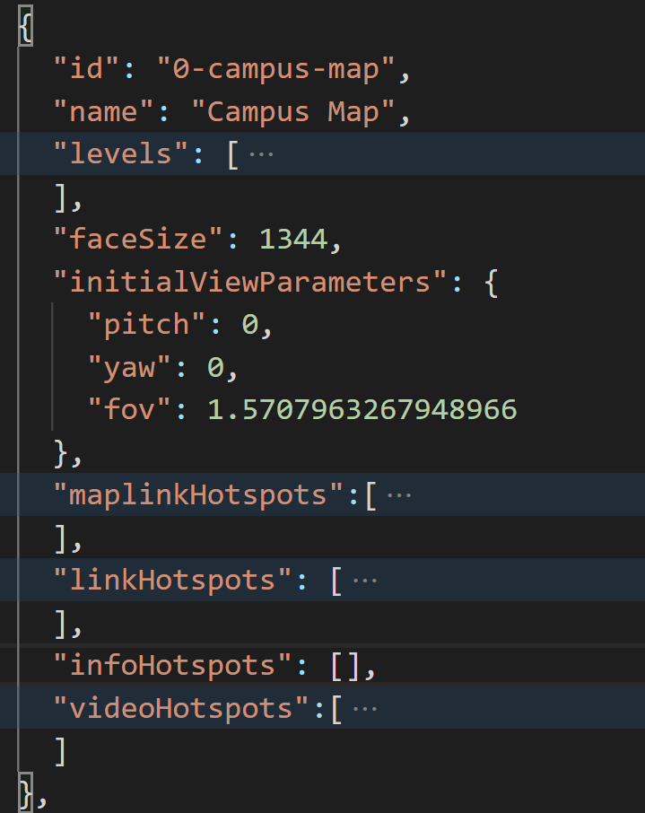

Organisation_Virtual_Tour/data.js

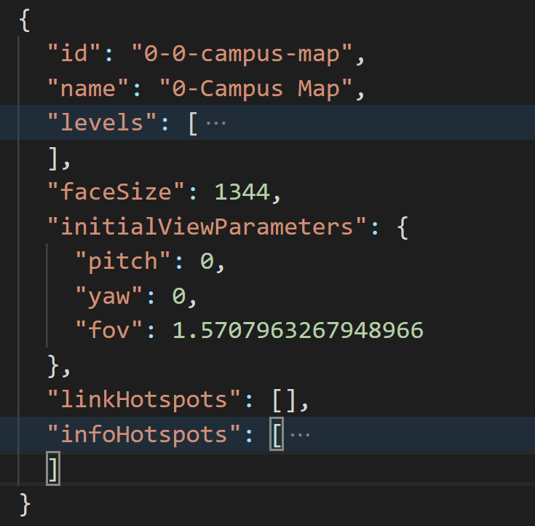

Organisation_Virtual_Tour/data.js

Marzipano_Virtual_Tour/data.js

*Note: Make sure you do not mis any “,” or “() [] {}”, otherwise it will result on an error. For example, the last element “videoHotspots” do not require a “,” at the end.*

*Note: Make sure you added the code to ALL scenes, otherwise it will result on an error.*

1. Copy and Replace the “Marzipano_Virtual_Tool/data.js” file with “Organisation_Virtual_Tour/data.js”.
2. We will come back to this later, after completing Step 4

### Integrate Accessible Sub-Grouped Menu

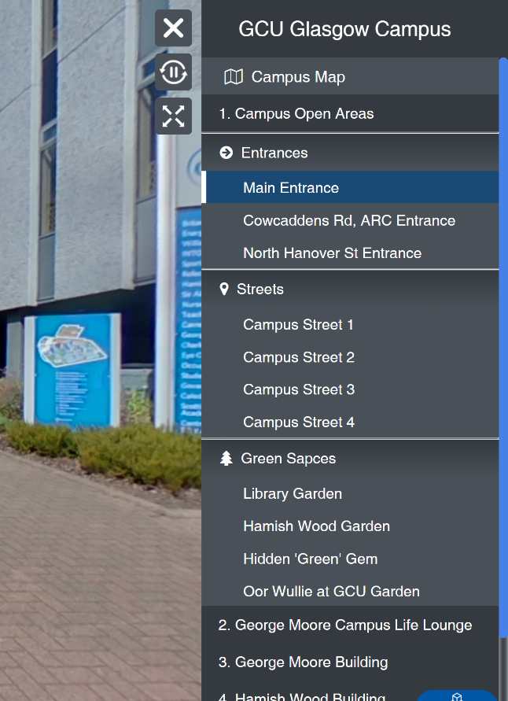

BREVE INTRODUCTION

The vertical menu is created with the combination of the three files:

1. index.html (provides content),
2. index.js (provides the functionality),
3. style.css (provide the style (design))

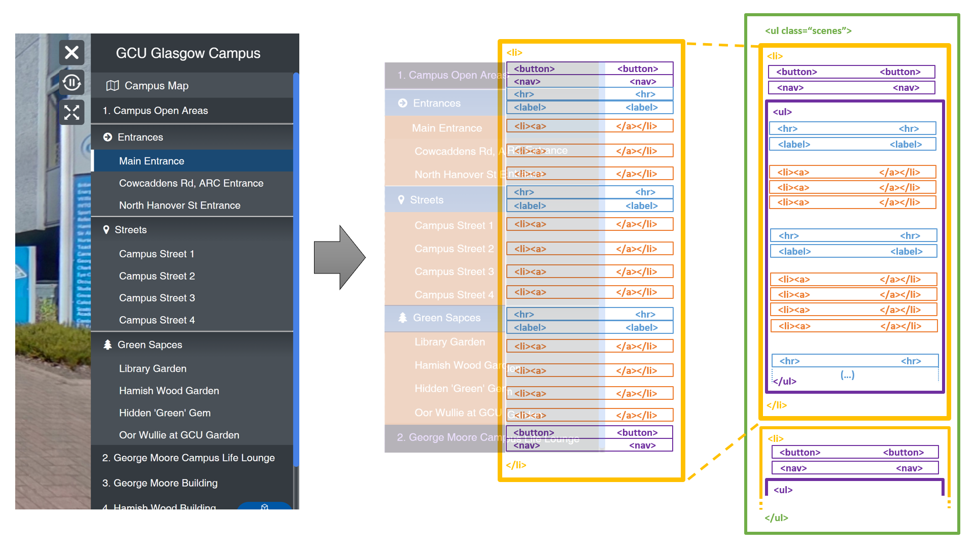The code structure is the following:

The resulting vertical menu follows the bellow structure, where each 360 image is coded with the following elements:



The important parts are:

* data-id: each 360 image id on the data.js file created (i.e. 1-cowcaddens-rd-main-entrance)
* 360_room_name: room name that appears on the vertical menu, which references each 360 image (i.e. Main Entrance)

STEPS

1. Open “Organisation_Virtual_Tour/index.html” file using an editor note (i.e. Visual Code).
2. 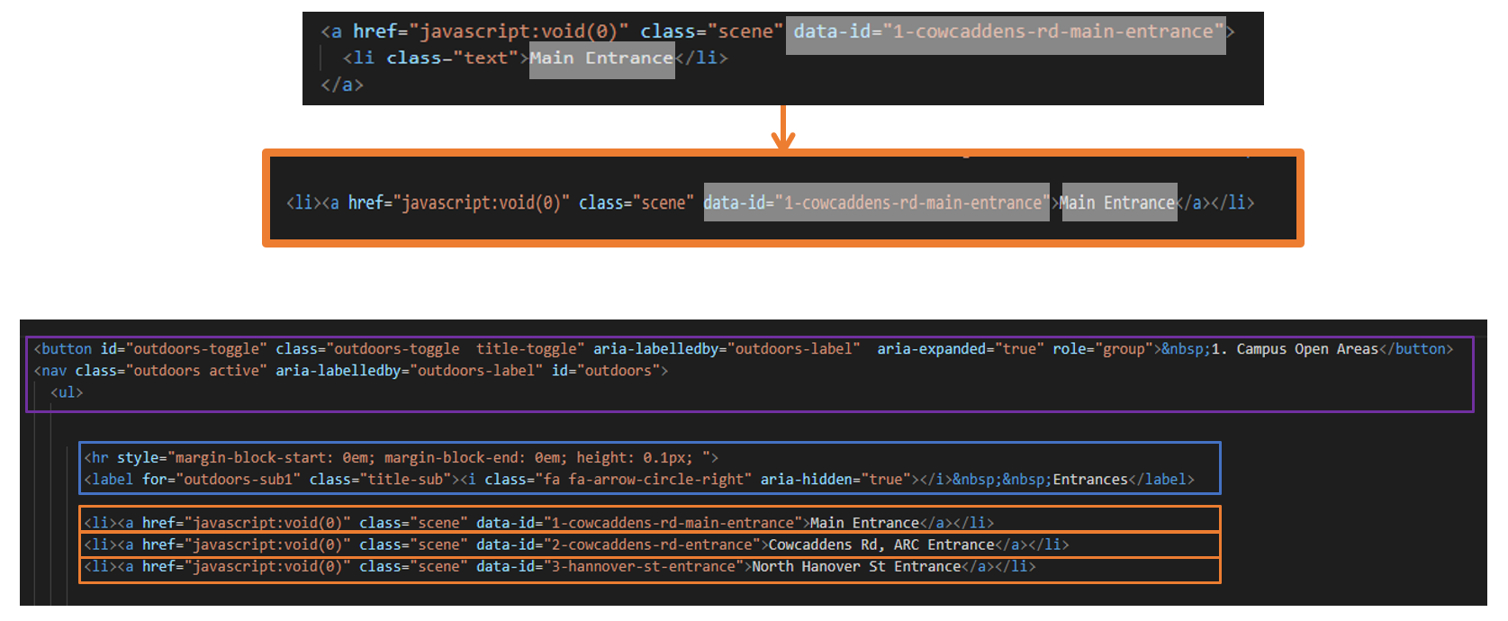Re-write the code lines from <a><li></li></a> to the following way <li><a></a></li>
3. Keeping in mind the code structure (described in the introduction of this section “Step 3.4”), group the scenes by groups adding the code line (squared in **blue** and **purple**) to obtain a header:



## Learning Record Stores (LRS) Set Up

This section describes few steps to create and set up the LRS account with your Virtual Tour (created with Marzipano and the software framework proposed).

### Create Learning Record Store account

[Follow STEP 2 from this tutorial](https://elearningart.com/blog/xapi/) to set up a Learning Record Store (LRS) that can receive data from outside sources. You will:

1. Get access to an LRS (this tutorial uses YetAnalytics)
2. Set up the LRS for xAPI statements

As a result, you obtain the following credentials that you will need on the next step.

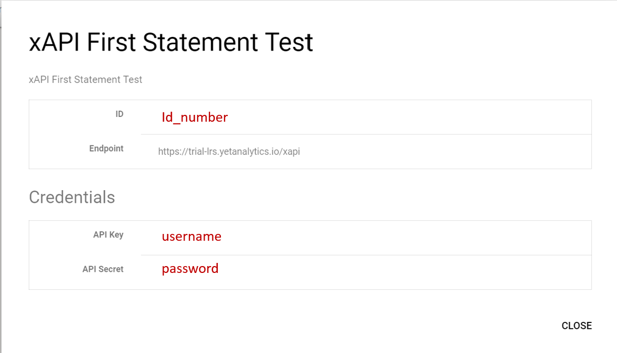

### Connect your website to the LRS and send statement

1. Open “Organisation_Virtual_Tour/index.js” file using an editor note (i.e. Visual Code).
2. Modify the following code line with your “xAPI LRS” Credentials obtained in “Step 4.1”:

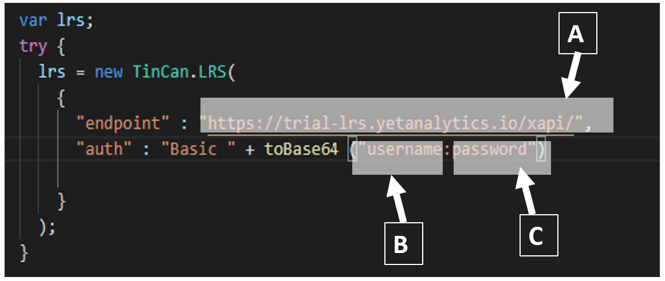

1. Endpoint = The URL from YetAnalytics (mine was: https://trial-lrs.yetanalytics.io/xapi). Note: make sure you keep the backslash!!!
2. API Key = username
3. API Key Secret = Password   
   Note: before the colon, you’ll do the “API Key” and after the colon is the “Key Secret”

### Run a Test

Now that you’ve created the tied the site to your LRS, you’ll need to trigger an event that will send that statement to your LRS

1. Run the “Organisation_Virtual_Tour/index.html”, right click on the “index.html” file and open with a browser (i.e. Google Chrome).
2. Navigate to a 360 image and click on an “Info Hotspot” element (i.e. Hamish Wood Building). See example on the image bellow:

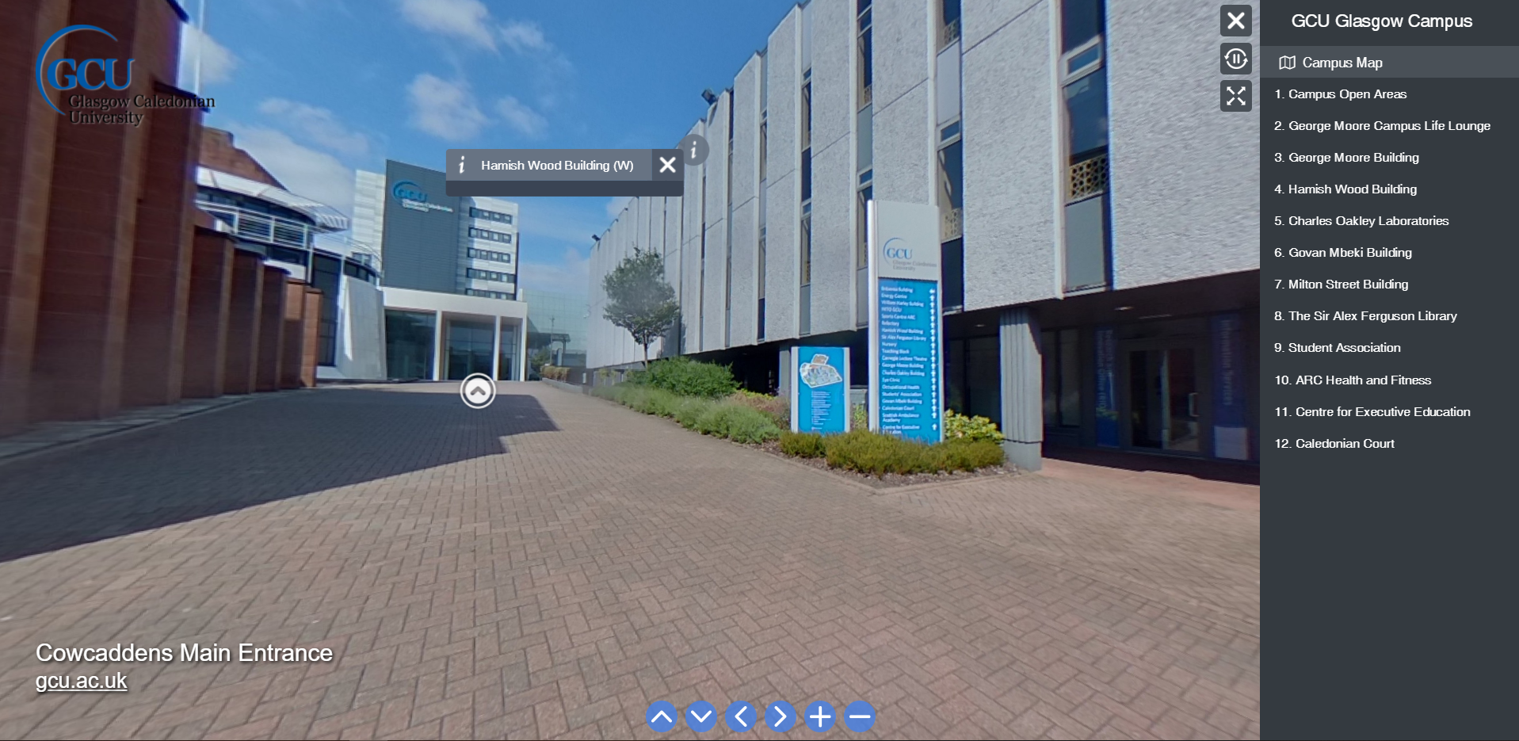

1. 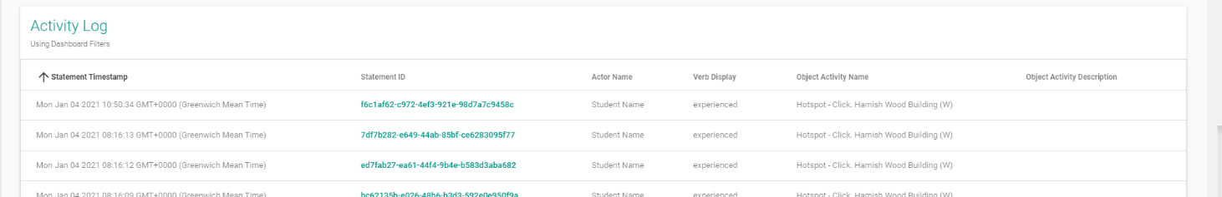Open up YetAnalytics, scroll down and you should see some analytics

## Host your Virtual Tour using Amazon S3 (AWS S3)

Note: There are many way to host your website, but this method worked for this project during the testing stage to share our work and receive feedback.

The bellow link provides an overview of how to [use “Amazon S3” service to host a static website](https://docs.aws.amazon.com/AmazonS3/latest/dev/WebsiteHosting.html).

[Check this other link](https://docs.aws.amazon.com/AmazonS3/latest/dev/HostingWebsiteOnS3Setup.html) to get a step-by-step tutorial on how to set Amazon S3 to web hosting. It describes how to:

1. configure a bucket for website hosting,
2. upload a sample index document,
3. test the website using the Amazon S3 website endpoint for the bucket.

[This other link](https://docs.aws.amazon.com/AmazonS3/latest/dev/website-hosting-custom-domain-walkthrough.html) shows how you can use your own domain, such as example.com, instead of the Amazon S3 bucket website endpoint, and serve content from an Amazon S3 bucket configured as a website.

## Create 3D Environment with Mozilla Hub and Add link to

### Create 3D environment and Link

1. Navigate to [https://hubs.mozilla.com/spoke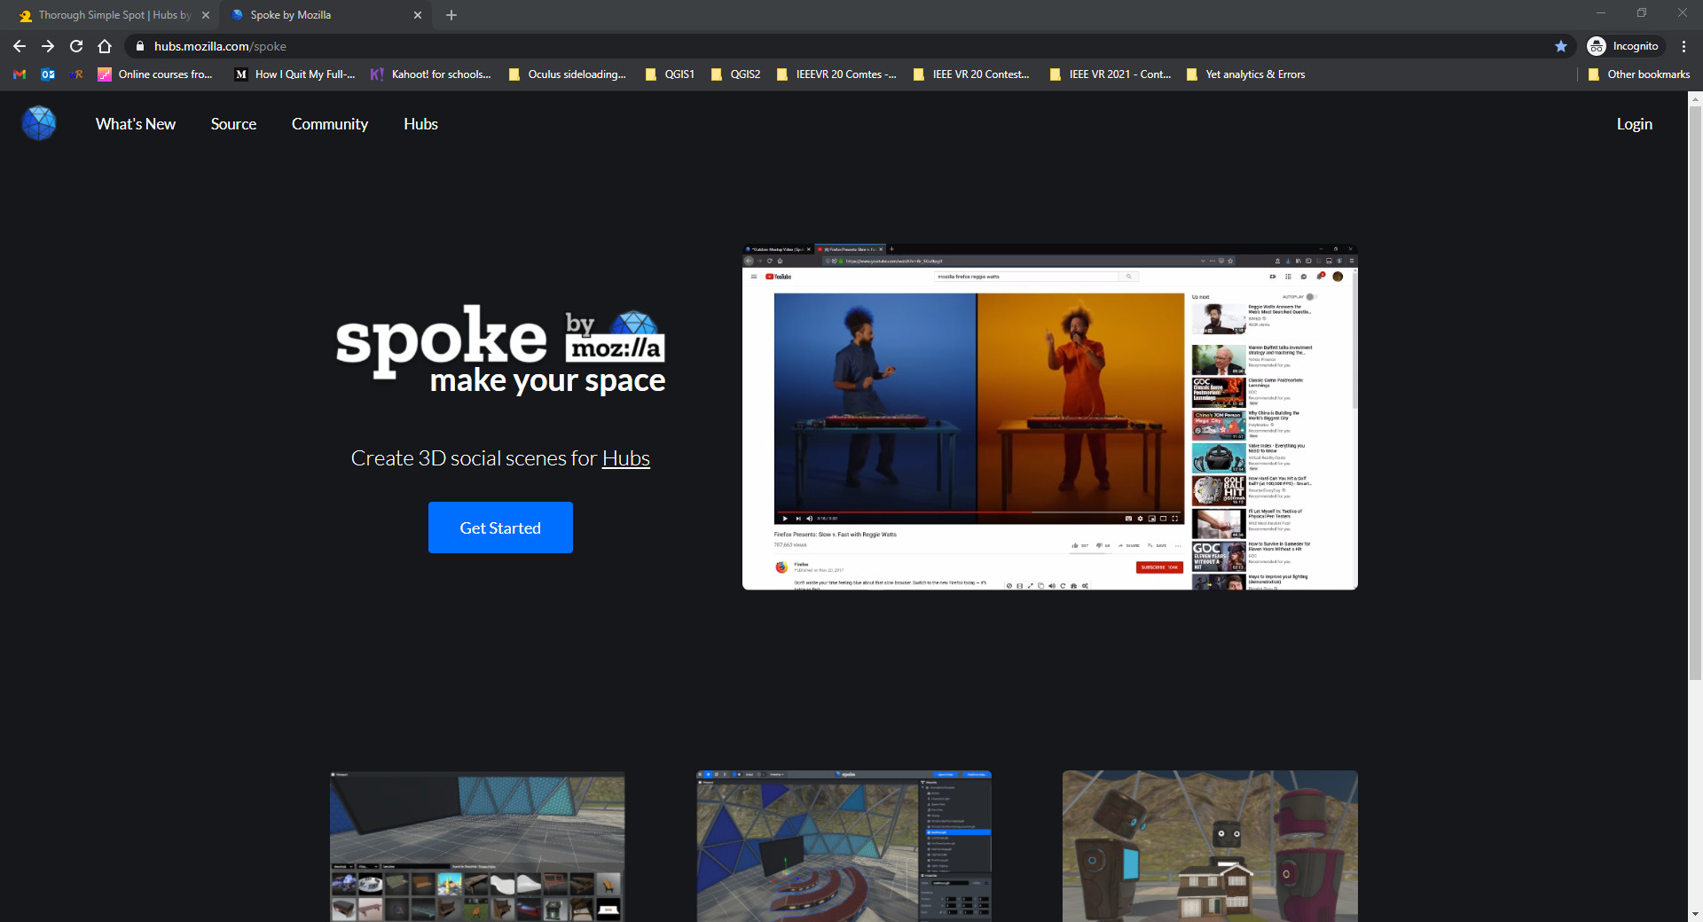](https://hubs.mozilla.com/spoke#)
2. Click on “Get Started” and “New Project”
3. Select an environment or select the option “New Empty Project” to create a 3D environment from scratch.
4. To add (embed) the web-based Virtual Tour, activate the “Experimental Features” clicking on the menu button (displayed as ≡) > “Developer” > ”Enable Experimental Features”

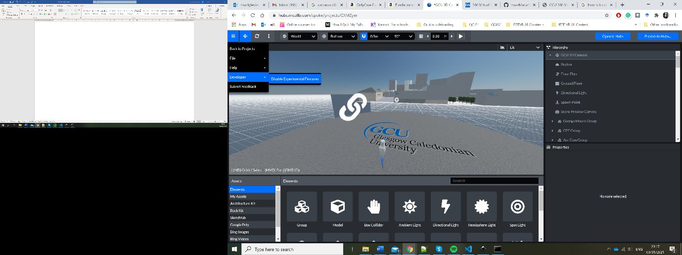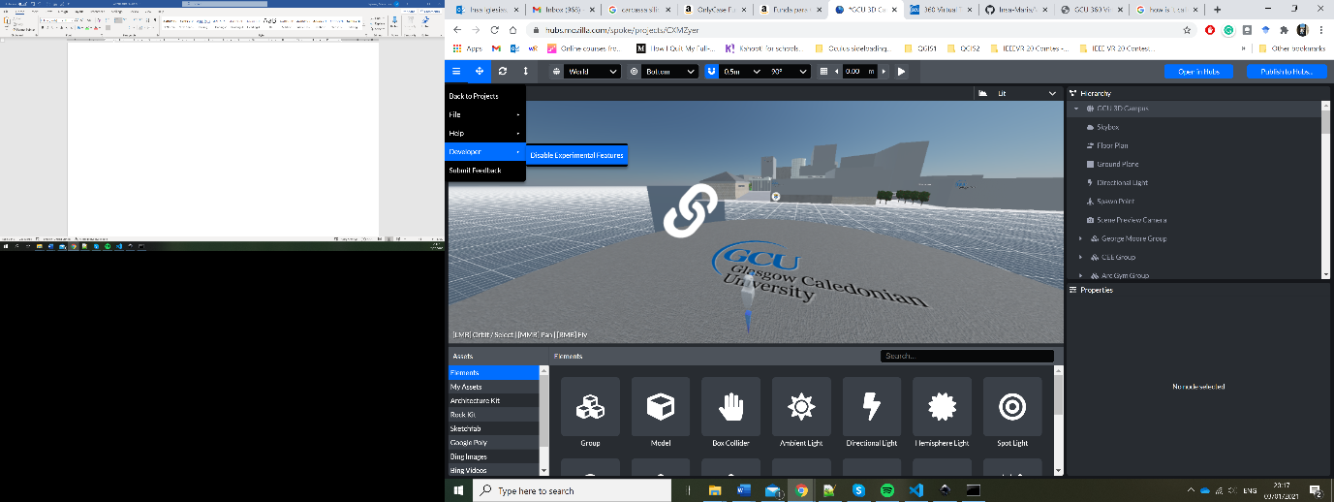

1. On the bottom navigation menu tagged “Assets”, click on “Elements” and click on “Link” to add it to the environment.

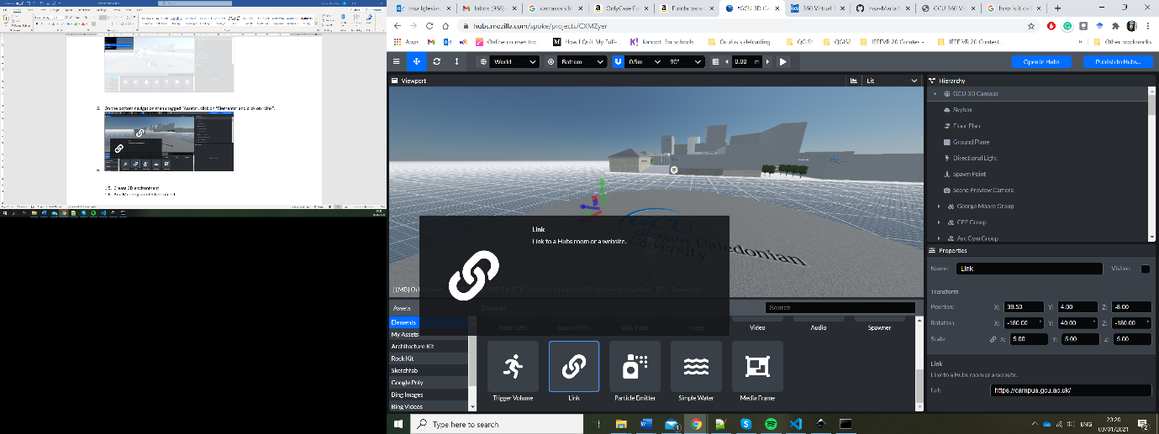

1. Set the position of the “Link” element and add the “Url” direction obtained after hosting the Virtual Tour (Step 4) (i.e. <https://campus.gcu.ac.uk/>).

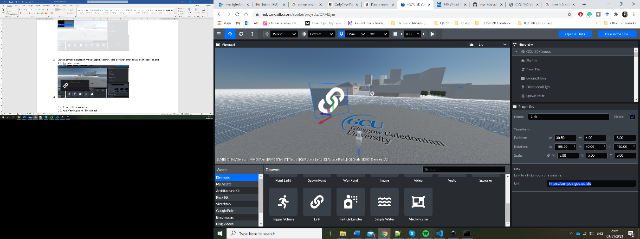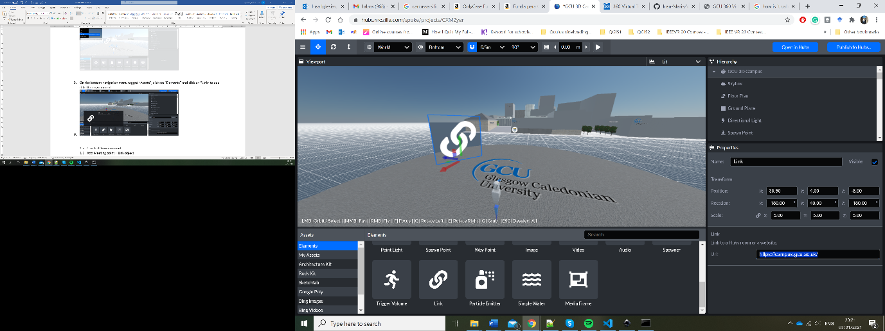

1. Click on the menu button (displayed as ≡) > “File” > “Save Project”
2. Click on the top left button “Publish to Hubs”

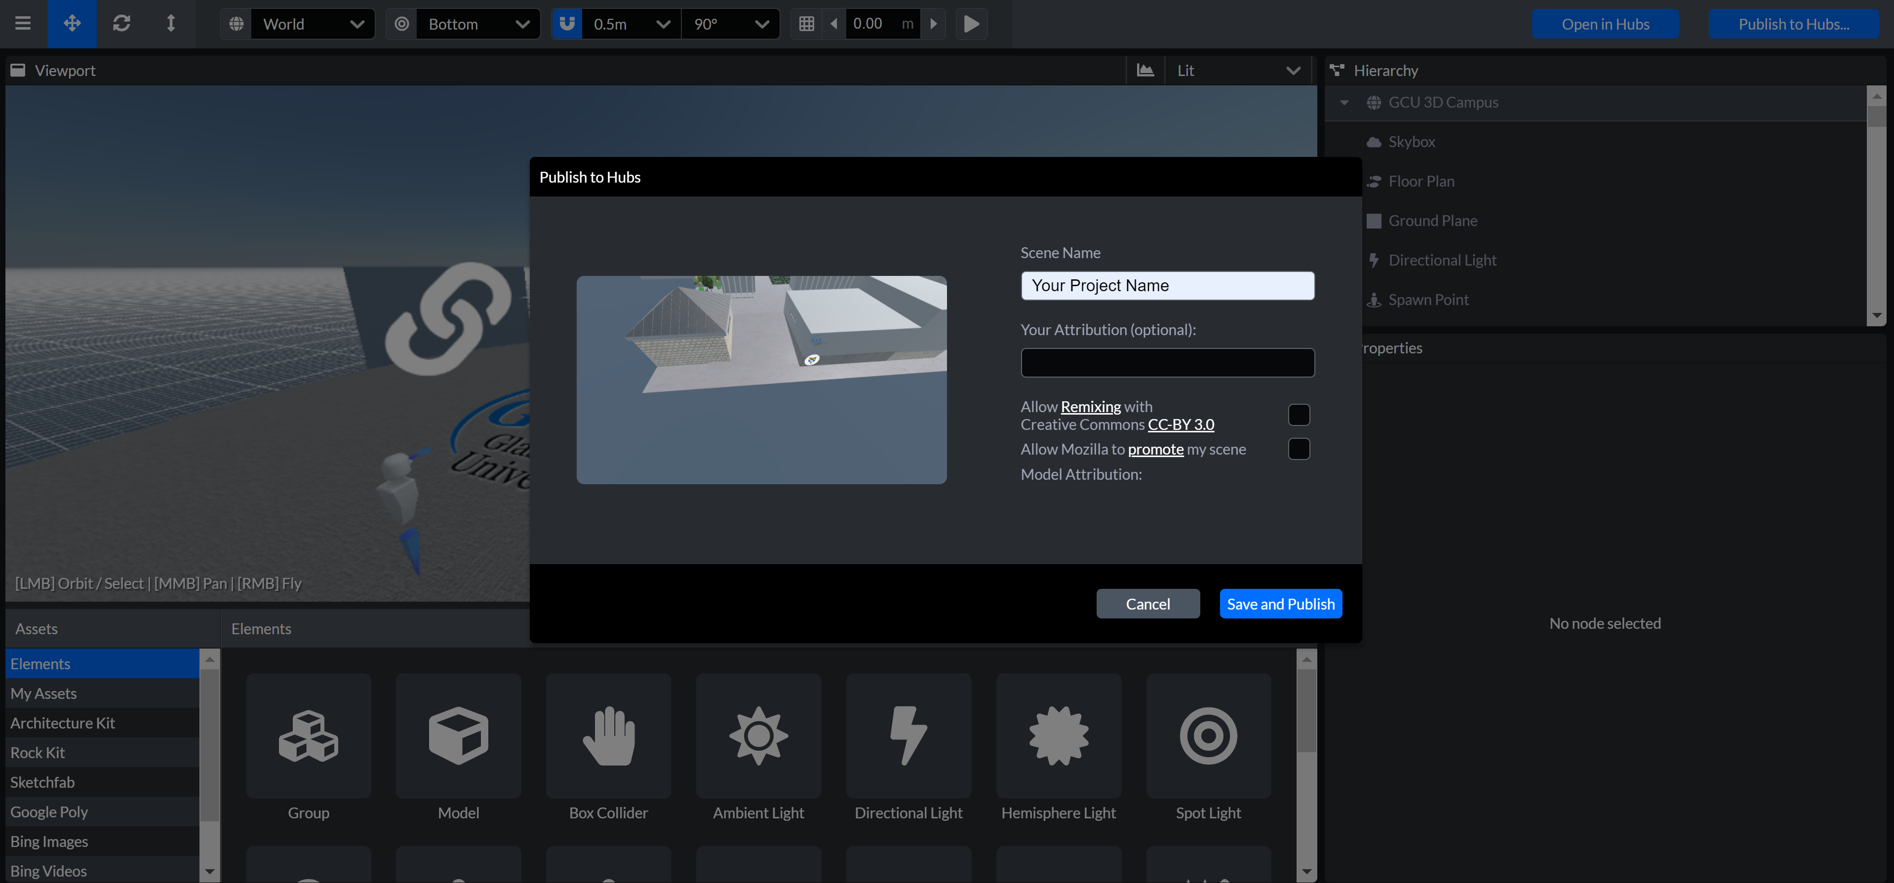

1. Set a “Scene Name” and click on “Save and Publish”
2. A “Performance Check” window appears and then click on “Publish Scene”
3. Once it has been published successfully, click on “View Your scene”.

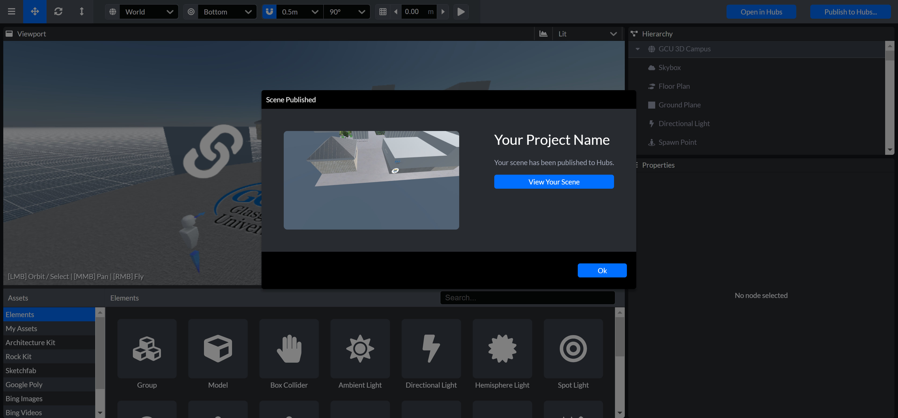  
Note: you can also view your project clicking on the top left button “Open in Hubs”, but you need first to save and publish it to see the last version you created.

### Get Link to Allow Users Log In

1. In Mozilla Hubs-Spoke, click on the top left button “Open in Hubs” to view your scene

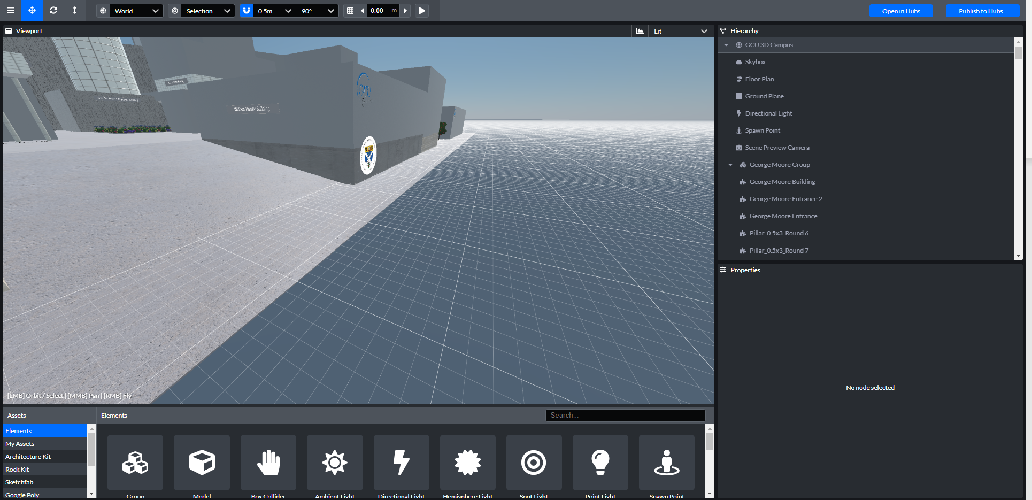

1. Click on “Create a room with this scene”

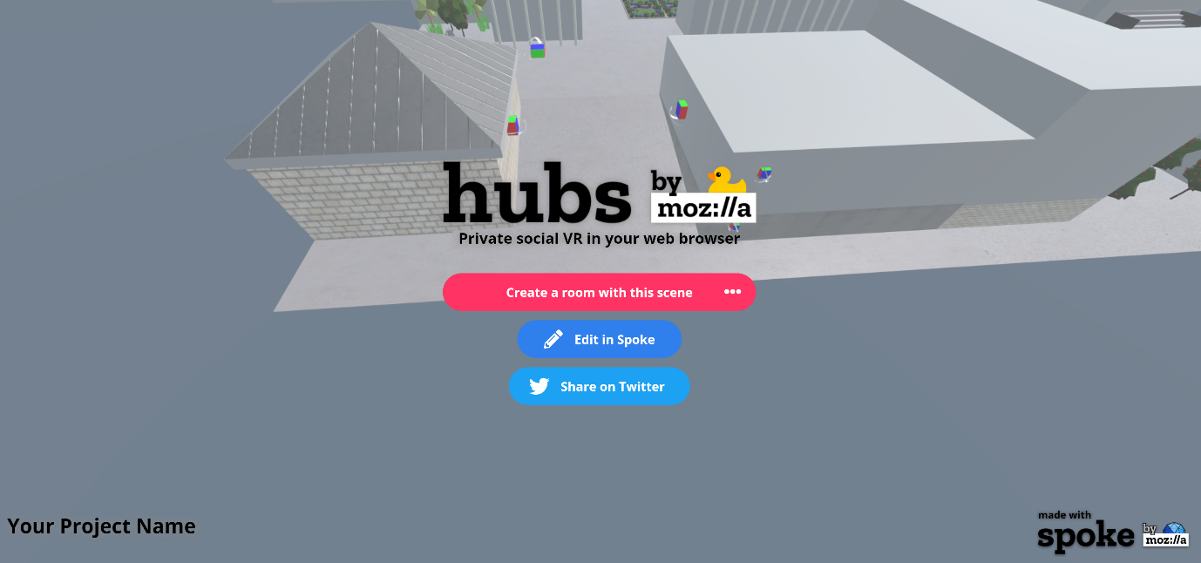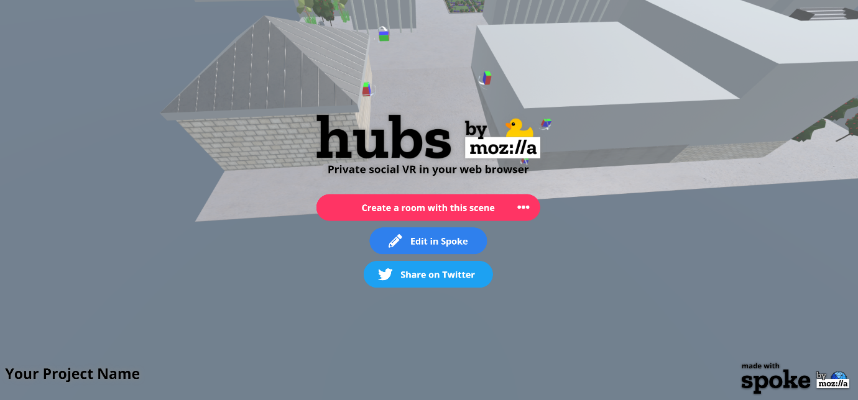

1. Click on the top button “Share”

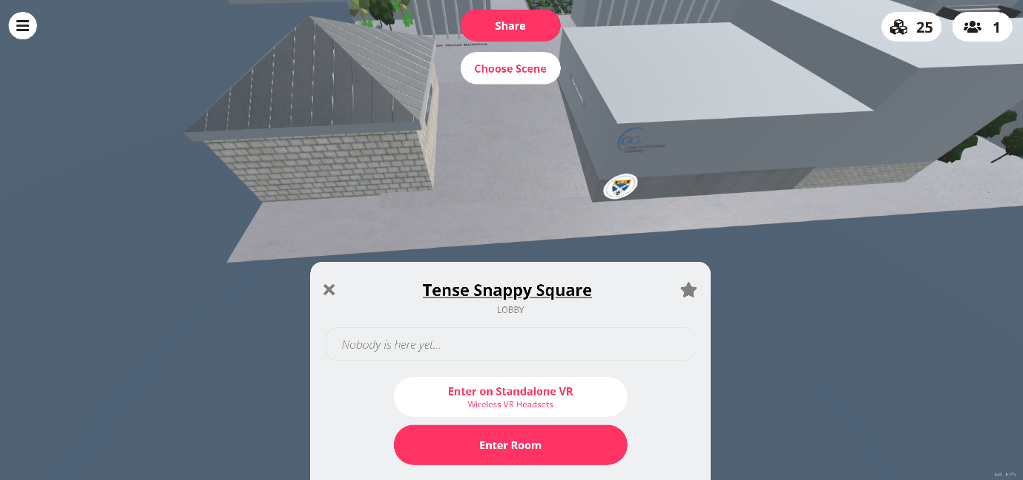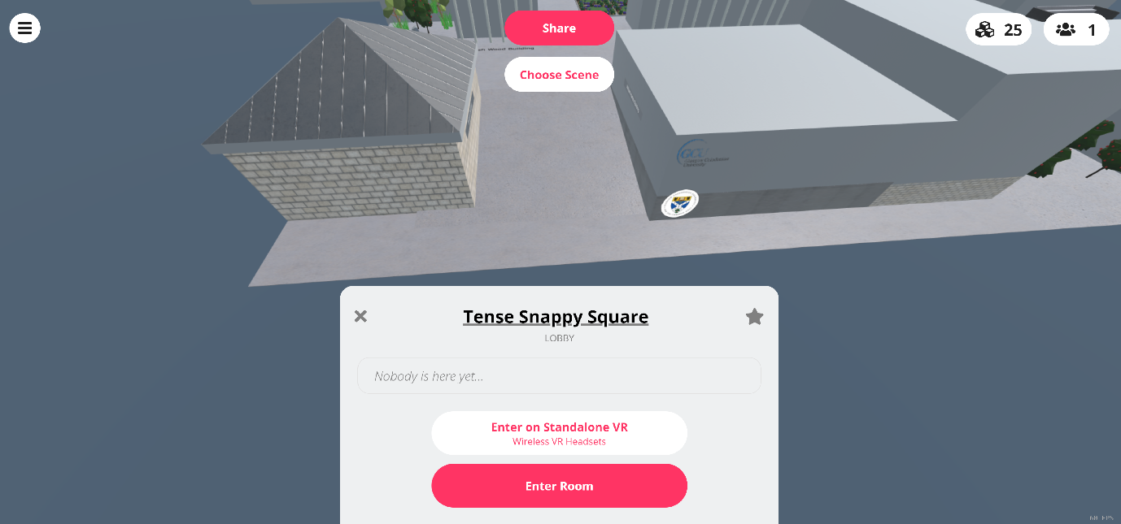

1. 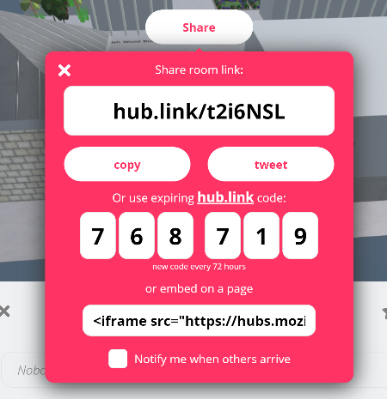Copy the text of the bottom box (starts with “<iframe sc….”).

For example:   
<iframe src="https://hubs.mozilla.com/t2i6NSL/tense-snappy-square?embed_token=19774a93784d0919379e90d22684ceda" style="width: 1024px; height: 768px;" allow="microphone; camera; vr; speaker;"></iframe>

1. From the copied text, save for later the Mozilla Hub link (highlighted in yellow). This will be the link you share with other visitors.  
     
   For example:   
   <https://hubs.mozilla.com/t2i6NSL/tense-snappy-square?embed_token=19774a93784d0919379e90d22684ceda>